  - CS5500
  - Task 1
Renuka Naineni
2371131
2371131@brunel.ac.uk
Batting and Bowling performance prediction of Cricket Players using Machine Learning Algorithms: A Comparative Analysis
Alan Serrano-Rico

Abstract
When it comes to international sports competitions, selecting the team involves predicting the performance of individual athletes. Cricket holds widespread popularity in many countries, making player selection a pivotal task. Player performance depends on various factors, such as the opposing team, the venue, and their current form. The player’s performance also depends on the type of match format, whether Test, ODI, or T20. The team management, coach, and captain must choose 11 players from a squad of 15 to 20 for each match. They analyse different player characteristics and statistics to select the best 11 for each game. Each batsman aims to contribute by scoring the maximum runs possible, while each bowler strives to take the most wickets and concede the fewest runs. This paper aims to predict player performance by estimating the expected number of runs for each batsman and the projected number of wickets for each bowler in a team using supervised learning techniques such as SVM, Random Forest and Neural Networks algorithms. We choose the best-performing model based on the performance evaluation.

Background

Cricket is a widely popular sport in many countries, featuring two teams of 11 players each. The teams are comprised of batsmen, bowlers, and a wicketkeeper, with some players serving as all-rounders capable of both batting and bowling. The batsmen aim to score runs while the bowlers strive to take wickets and limit the opposition's runs. Cricket is played in various formats such as Test cricket, One Day International (ODI), Twenty 20 (T20), and premier leagues, with each format having a different number of overs or match duration. A standard over consists of 6 balls. These tournaments yield significant revenue from ticket sales, advertising, and marketing. Team selection is a crucial aspect, with coaches, selection committees, and captains extensively analyzing player performance statistics to make well-informed decisions regarding team composition based on factors such as format, pitch conditions, and the opposition. These insights are also valuable for marketers and brands in selecting the most suitable players and teams for advertising and marketing campaigns.

Not many studies were conducted in this regard but there are a few research papers that have been published to predict cricket player performance in the past few years in various formats.

Passi, Kalpdrum & Pandey, Niravkumar. (2018) are among the few who used a generalized approach to predict the number of runs a batsman will score and the number of wickets a player will take on a particular match day. Their models were run on a combination of derived attributes which are obtained from traditional batting attributes and bowling attributes like average runs given, strike rate, 100s scored, 50s scored, economy rate, 3 wicket hauls, 5 wicket hauls etc. The classification models Naïve bayes, Random Forest, SVM and Neural Networks were used to predict the player performance with random forest giving the best results. The research was only considering the ODI format and has not been extended to T20 format

In an IEEE research paper, A. I. Anik (2018) tried to predict the runs scored by a batsman and the runs conceived by a bowler by using the SVM machine learning model with linear and polynomial kernels for Bangladesh team players. They restricted the model to only the specific team, and the model had very high accuracy for a few players and low accuracy for other players. The research focused mainly on Bangladesh players and was restricted to only few parameters limiting its scope and in consistent accuracies for different players.

Iyer, S. R., & Sharda, R. (2009) used neural networks to classify the players into ‘performer’, ‘Moderate’, and ‘failure’ categories. They used the players' past data and classified them into categories based on their different attributes. The study is confined to the heuristics defined by the authors for the players' ICC World Cup tournament but could not be extended to other tournaments. Only neural networks were considered and not any machine learning models with limitation to how the heuristics were used.

Sanjaykumar S et al. (2024) have predicted the Player performance using various performance measures and did a comparative study of how the Support vector Regression, XGBoost and Random Forest models are performing, but this study was only limited to very few attributes and have not considered a lot of factors influencing the player performance.

In his paper, Lemmer, H. H. (2008) has shown how the batting and bowling performance measures of the ODI format can be adapted for the T20 format, especially when a particular player plays few matches. The limited data on the T20 during 2008 has limited to study T20 performance based on ODI formats, but with new gaming rules and players adoption to T20 format this might result in different results now.

Dibyojyoti and Darshan (2012), in their paper, predicted the bowler's performance by using the Combined bowling rate, which is an arithmetic mean of the Bowling average, the bowling strike rate and the Economy rate. It was concluded that bowler experience and the combined bowling rate are the most important factors influencing the bowler performance in the Twenty 20 International.

From the above literature review it can be seen that not enough studies were conducted on predicting the player performance in T20 formats, the detailed studies were either limited to ODI formats or very few parameters were taken into consideration limiting the scope of the studies, So this research is conducted to address this gap to build models to predict the batting and bowling performance of cricket players in T20 format.

Many studies have been done to predict player performance in other sports as well like football, handball, Rugby, Tennis etc but as cricket is unique like any other game, the studies regarding cricket have only been taken into consideration for this dissertation

Aims and Objectives

Aim: To predict a player’s performance in Twenty 20 (T20) matches by analysing their historical performance data using supervised machine learning techniques

Objectives:

- To explore open source databases and also sports websites to find the relevant datasets.
- To perform data cleaning and data merging of different tables is done on extracted data.
- From the variables chosen, to define and classify various performance measures, such as consistency, form, opposition, etc., and then modify the data accordingly to suit the model-building.
- To build the machine learning models for batsman and bowler performance separately.
- To evaluate model performance and fine-tune the parameters to improvise the models.
- To critically analyse and evaluate the results.

Approach

There are various methodologies that can be opted like Cross-Industry Standard Process for Data Mining (CRISP-DM), Knowledge Discovery in Databases (KDD), ‘Sample, Explore, Modify, Model, Assess’ (SEMMA), Agile Methodology, Waterfall Methodology etc. Agile and. Waterfall methodologies are mostly suited for Software development projects where as the others CRISP-DM, KDD and SEMMA are suited for data mining and Analytical projects. For this dissertation, we would adopt the CRISP-DM methodology.

CRISP-DM stands for Cross-Industry Standard Process for Data Mining. It is a cyclical process that provides a structured approach to planning, organizing, and implementing a analytical project. The major phases are,
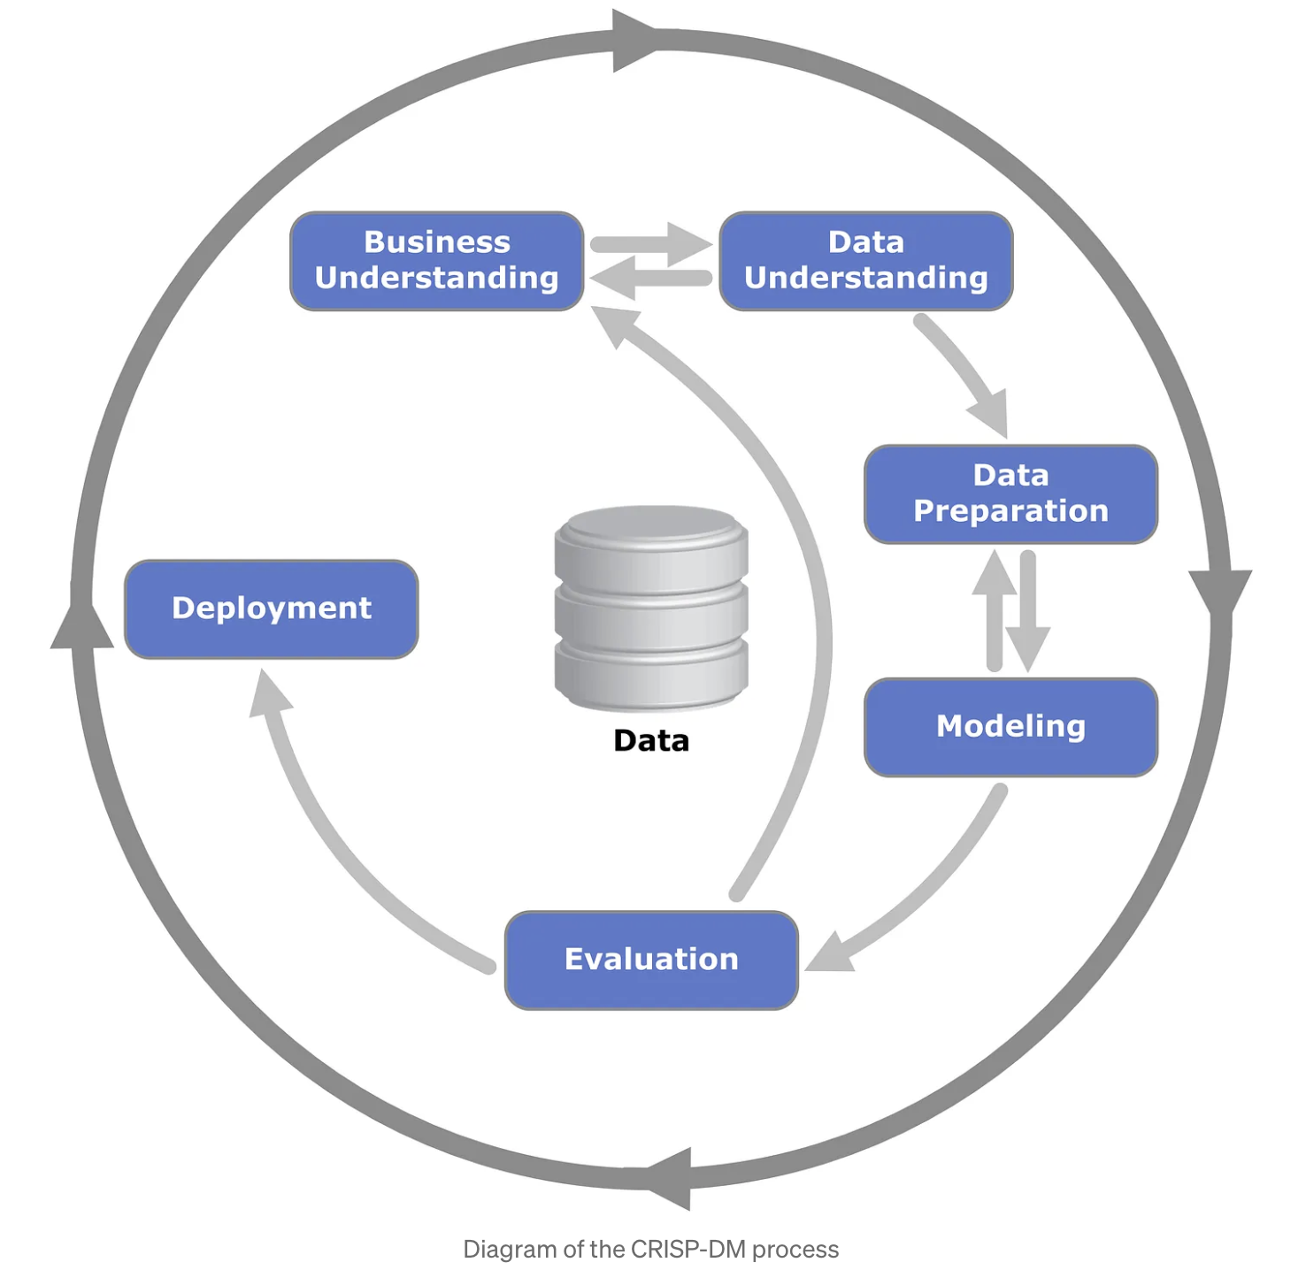
Business Understanding: The first phase emphasizes understanding the project objectives and requirements from a business perspective. It involves defining the problem statement, setting the project goals, and determining the success criteria. This phase ensures that the data mining efforts align with the strategic objectives and deliver meaningful insights. Key activities include:
- Determining business objectives.
- Assessing the current situation.
- Establishing data mining goals.
- Producing a project plan.

Data Understanding: In the Data Understanding phase, the focus shifts to acquiring and familiarizing oneself with the data. This involves collecting initial data, identifying data quality issues, and gaining preliminary insights. It helps to uncover the initial insights and detect potential data issues early in the project. Key activities include:
- Collecting initial data.
- Describing and exploring the data.
- Verifying data quality.

Data Preparation: Data Preparation is a critical phase where raw data is transformed into a suitable format for analysis. This phase involves data cleaning, integration, selection, and transformation. It ensures that the data is ready for the modeling phase and that the quality of the data is up to standard. Key activities include:
- Selecting relevant data.
- Cleaning data.
- Constructing data (feature engineering).
- Integrating data from multiple sources.
- Formatting data.

Modeling: In the Modeling phase, various modeling techniques are selected and applied to the prepared data. Different algorithms may be tested to find the best model that meets the project objectives. This phase requires fine-tuning model parameters and often involves multiple iterations to optimize performance. Key activities include:
- Selecting modeling techniques.
- Designing test scenarios.
- Building models.
- Assessing model performance.

Evaluation: The Evaluation phase involves thoroughly assessing the model to ensure it meets the business objectives and answering the original problem. It includes evaluating the model results, reviewing the steps executed, and determining whether the model is ready for deployment. Key activities include:
- Evaluating model results.
- Reviewing the modeling process.
- Deciding on the next steps.

Deployment: The final phase, Deployment, focuses on implementing the model in a real-world environment. This can range from generating a report to integrating a model into a decision-support system. This phase also includes planning for monitoring and maintenance to ensure the model continues to perform well over time. Key activities include:

- Planning deployment.
- Monitoring and maintaining the system.
- Producing final reports.
- Reviewing the project

4.Plan

A detailed plan is mentioned in the below table, week 1 starts on May 20th 2024

 |  | Week number:
Task ID | Task Name | 1 | 2 | 3 | 4 | 5 | 6 | 7 | 8 | 9 | 10 | 11 | 12 | 13 | 14 | 15
1 | Topic selection
2 | Literature review and topic finalisation |  |  |  |  | ¸ˇ
3 | Data collection and cleaning
4 | Feature selection and analysis |  |  |  |  |  |  |  |  | ¸ˇ
5 | Design and development of Models
6 | Training and Testing the Models |  |  |  |  |  |  |  |  |  |  | ¸ˇ | ¸ˇ
7 | Performance Evaluation of Models
8 | Report writing
9 | Submission of draft report including feedback |  |  |  |  |  |  |  |  |  |  |  |  |  | ¸ˇ
10 | Final Submission

References

Iyer, S. R., & Sharda, R. (2009). Prediction of athletes performance using neural networks: An application in cricket team selection. Expert Systems With Applications, 36(3), 5510-5522. https://doi.org/10.1016/j.eswa.2008.06.088.

Sanjaykumar S, Karthikeyan U, Rajendiran G, Cretu M, Kozina ZL. Cricket performance predictions: a comparative analysis of machine learning models for predicting cricket player’s performance in the One Day International (ODI) World Cup 2023. Health, Sport, Rehabilitation. 2024;10(1):6-19. https://doi.org/10.58962/HSR.2024.10.1.6-19
Lemmer, H. H, An analysis of players’ performances in the first Cricket Twenty20 World Cup series. South African Journal for Research in Sport, Physical Education and Recreation, 2008, 30(2): 71-77.

A. I. Anik, S. Yeaser, A. G. M. I. Hossain and A. Chakrabarty, "Player’s Performance Prediction in ODI Cricket Using Machine Learning Algorithms," 2018 4th International Conference on Electrical Engineering and Information & Communication Technology (iCEEiCT), Dhaka, Bangladesh, 2018, pp. 500-505, doi: 10.1109/CEEICT.2018.8628118.

Bhattacharjee, Dibyojyoti & Pahinkar, Darshan. (2012). Analysis of Performance of Bowlers Using Combined Bowling Rate. International Journal of Sports Science and Engineering, 6 (2012) 3, pp 184-192

Passi, Kalpdrum & Pandey, Niravkumar. (2018). Predicting Players' Performance in One Day International Cricket Matches Using Machine Learning. 111-126. 10.5121/csit.2018.80310.

ESPNcricinfo (2024) Cricket Teams, Scores, Stats, News, Fixtures, Results, Tables. Available: https://stats.espncricinfo.com/ci/engine/stats/index.html [Accessed: 10-Jun-2024].

Howstat (2024) howstat.com - The cricket statisticians. Available: http://howstat.com/cricket/home.asp [Accessed: 13-Jun-2024].

Shawn Chumbar (2023) The CRISP-DM Process: A Comprehensive Guide. Available: https://medium.com/@shawn.chumbar/the-crisp-dm-process-a-comprehensive-guide-4d893aecb151#:~:text=The%20CRISP%2DDM%20process%20offers,problem%20to%20deploying%20the%20solution. [Accessed: 26-Jun-2024].

